**APPROCH NOTE & OUTPUT SCREENSHOTS**

WHEN MANAGER LOGINS:

* List of employees whose status is ‘not_requested ’ and those who are under those manager who login is displayed when the manager login using Redux Saga and saved it in state.

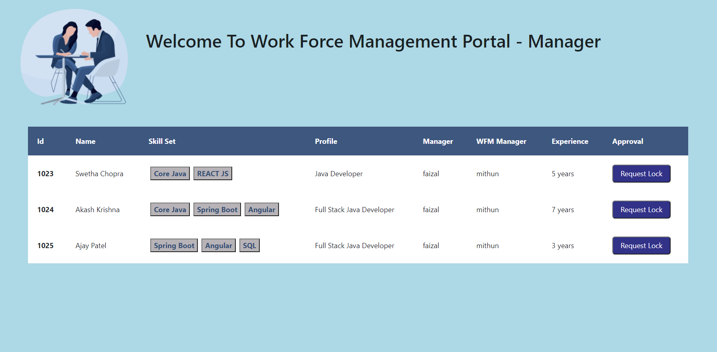

* When clicking on ‘Send Approval’ the corresponding employee details is fetched from state using ‘selector’ and the popup form appears to send request for approval to the corresponding WFM member.

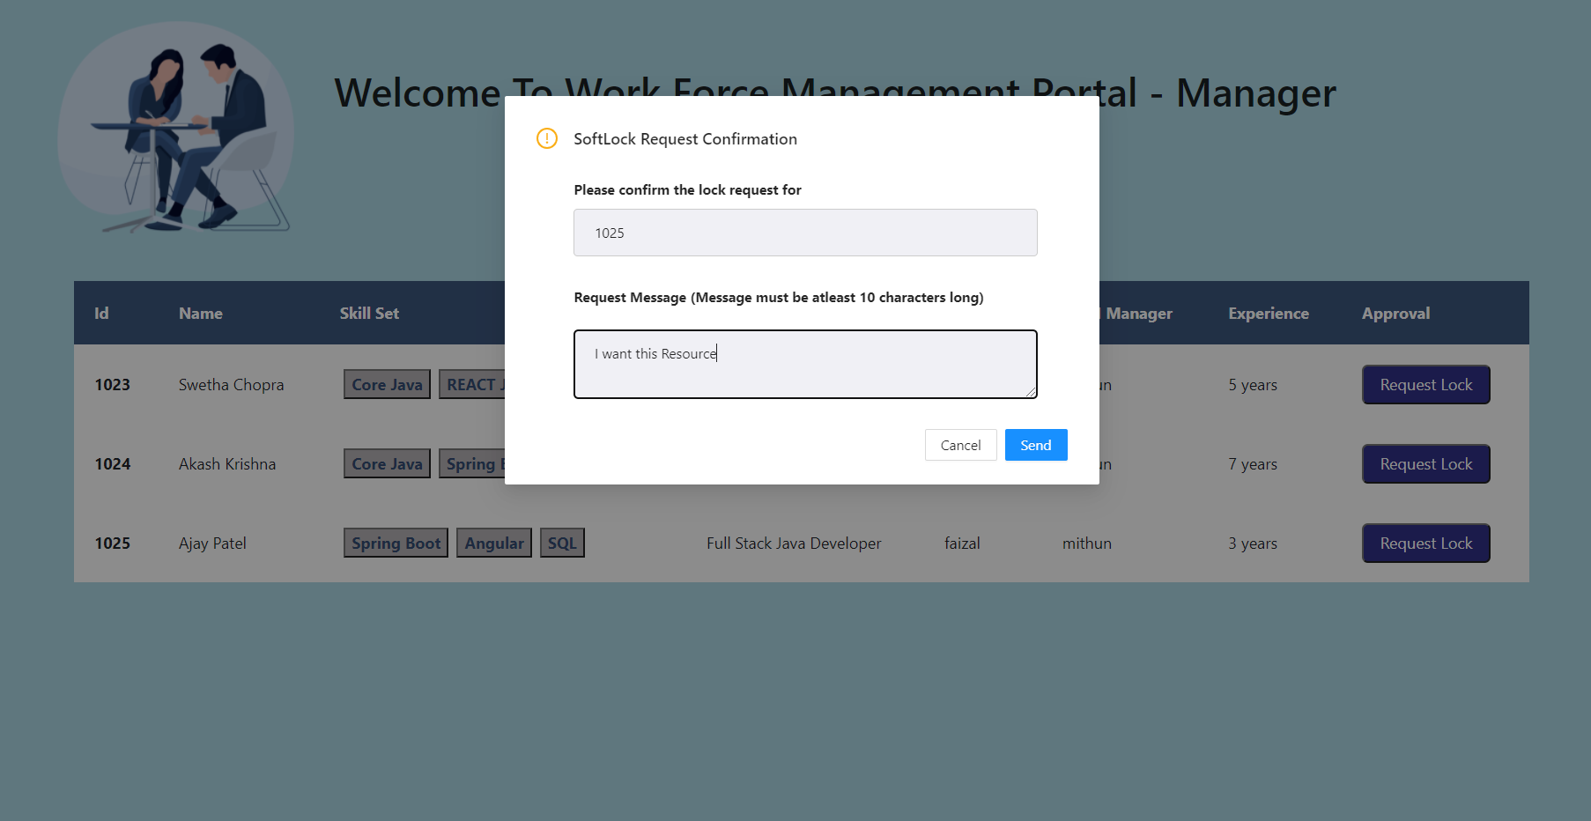

* Once the ‘Send’ button is clicked the request gets inserted into the softlock table with managerstatus as ‘awaiting_confirmation’ and also updated the lockstatus of that employee from ‘not_requested’ to ‘request_waiting’.
* And once the request is sent for approval that employee will be automatically removed from the list of employees that is displayed to that manager without refreshing the page as their lockstatus is changed from ‘not_requested’ to ‘request_waiting’ and a alert message appears at the top as ‘The Request is Successfully sent for Approval’ as shown in below screenshot.

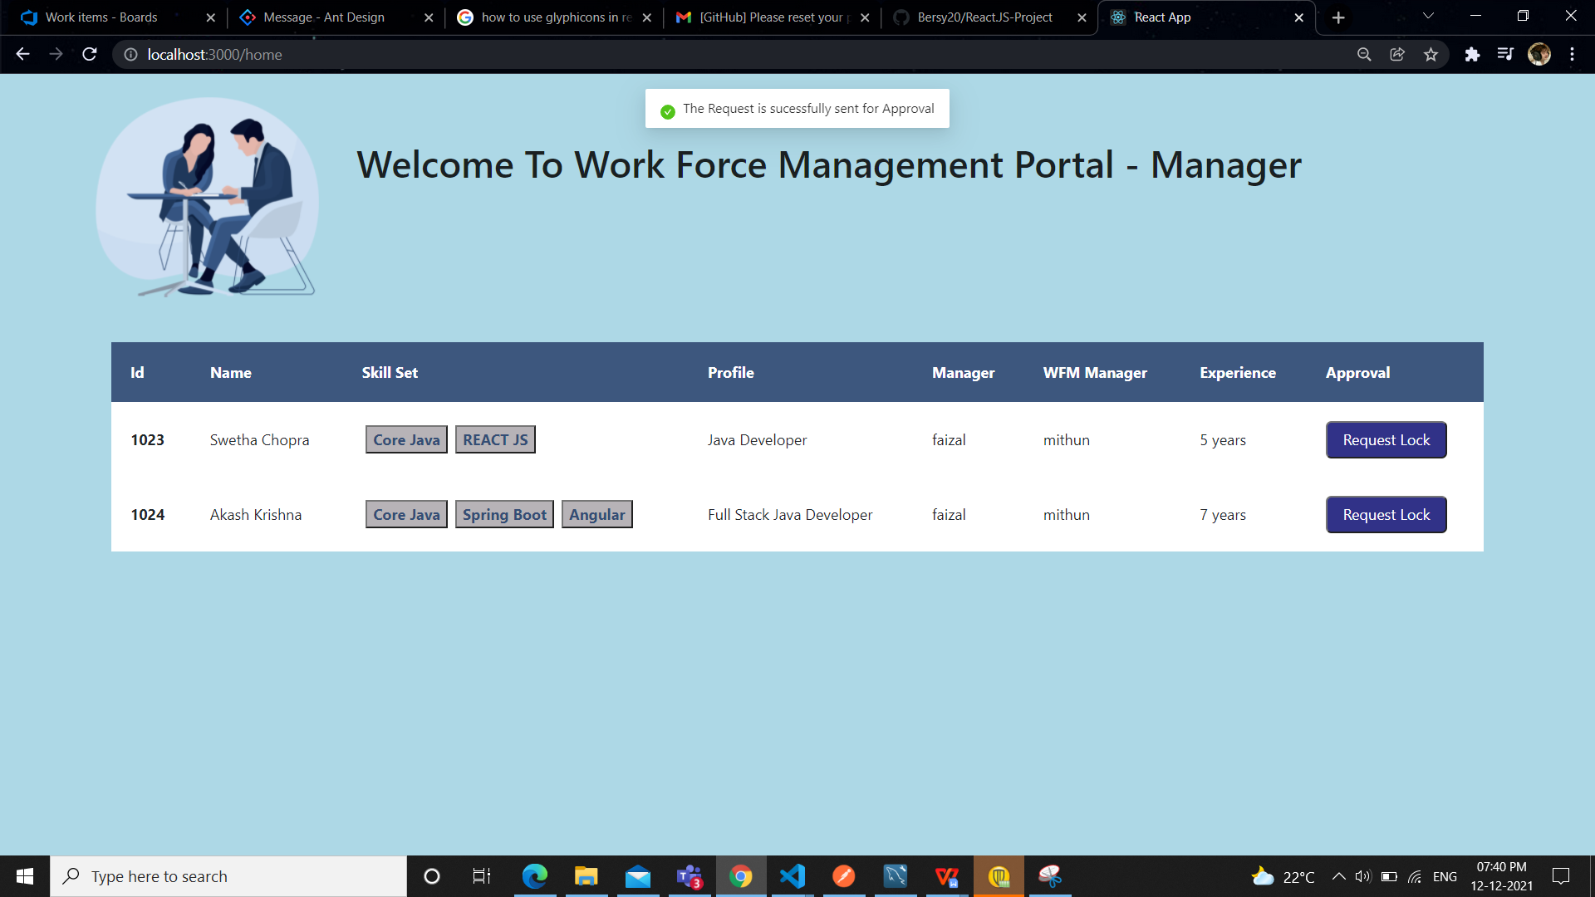

WHEN WFM MEMBER LOGINS:

* List of employees who are under him and managerstatus is ‘awaiting_confirmation’, status is ‘waiting’ and lockstatus is ‘request_waiting’ is displayed when the WFM Member login using Redux Saga and saved it in state.

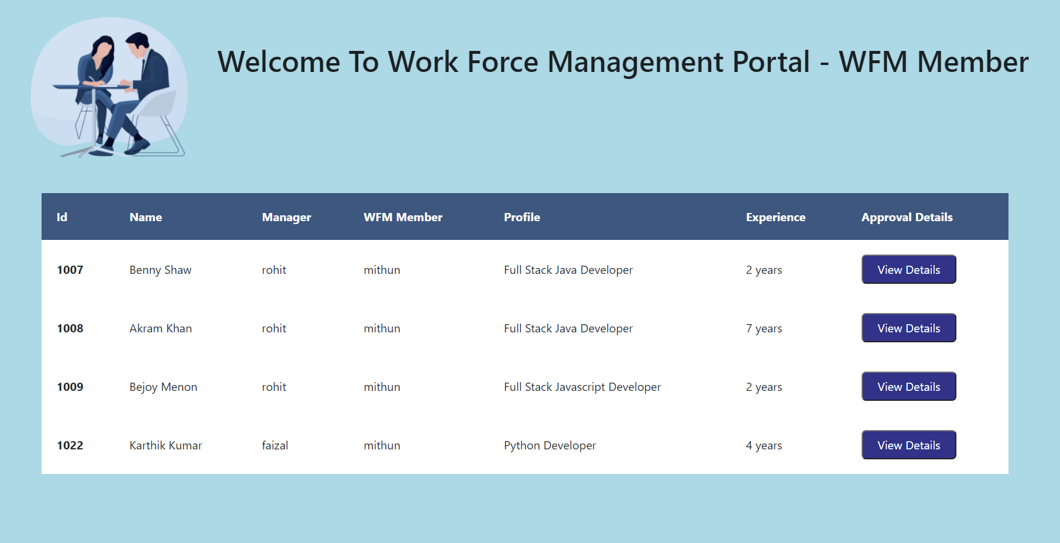

* When clicking ‘View Details’ button a pop up form occurs which displays the details of that employee which are fetched from softlock table using Redux Saga.
* The WFM Member cannot edit other details of that employee and can only Approve/ Decline the request.

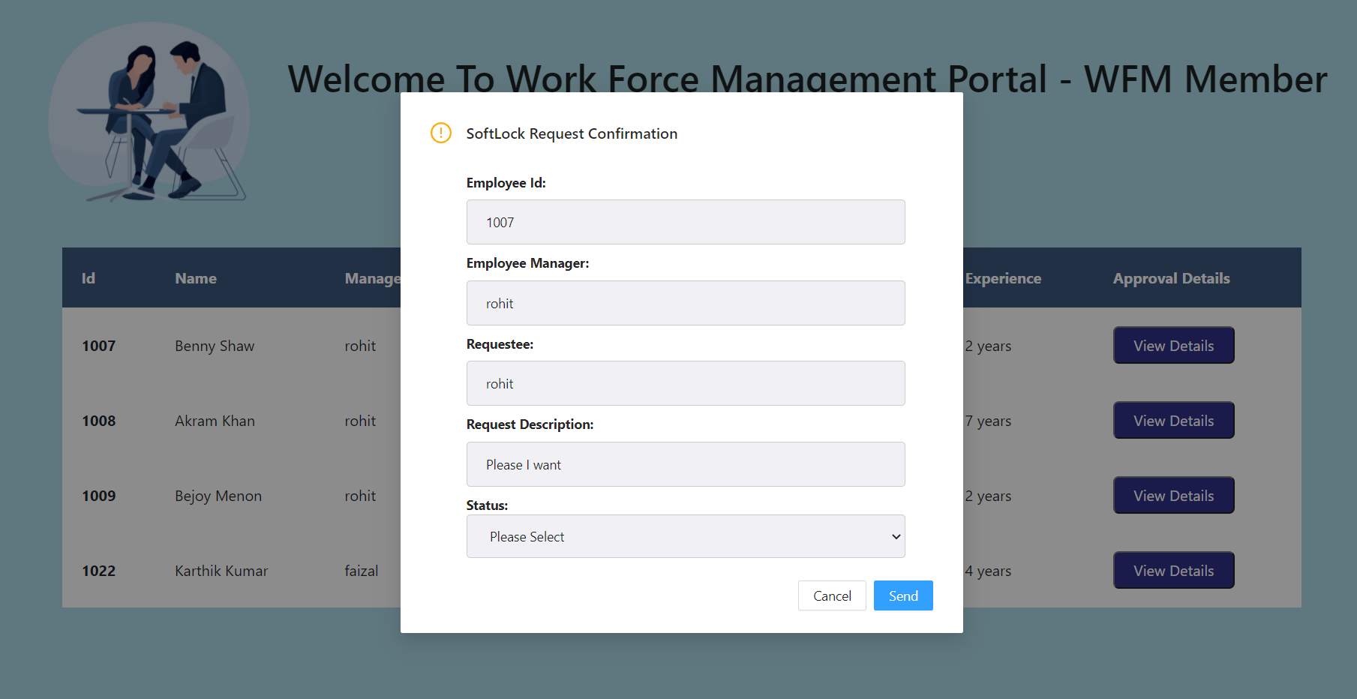

* When the WFM Member Approve/Decline the request and click on ‘Send’ button that employee will be removed from the list of employees automatically without refreshing the page and popup message will be displayed as ‘The Request is Updated’ as shown in the last screenshot in next page.
* If the request is approved then the following updates are made: status as ’approved’ , managerstatus as ’accepted’ and lockstatus as ’locked’.
* Similarly, If the request is declined then the following updates are made: status as ‘approved’ , managerstatus as rejected and lockstatus as ‘locked’.

